**Day 7 – tasks output**

1. **Rest countries based on Asia region using filter:**

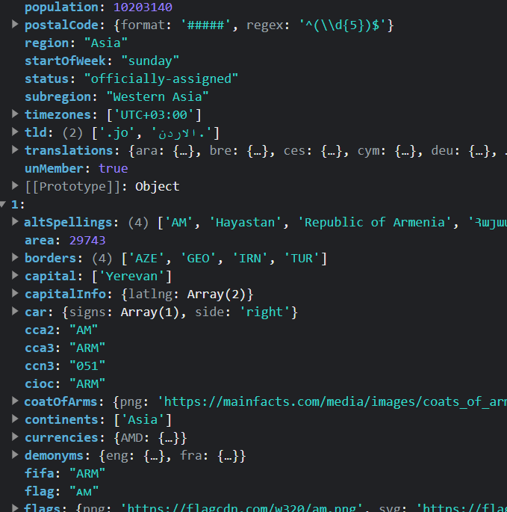

1. **Rest countries based on 2 lakh population by filter:**

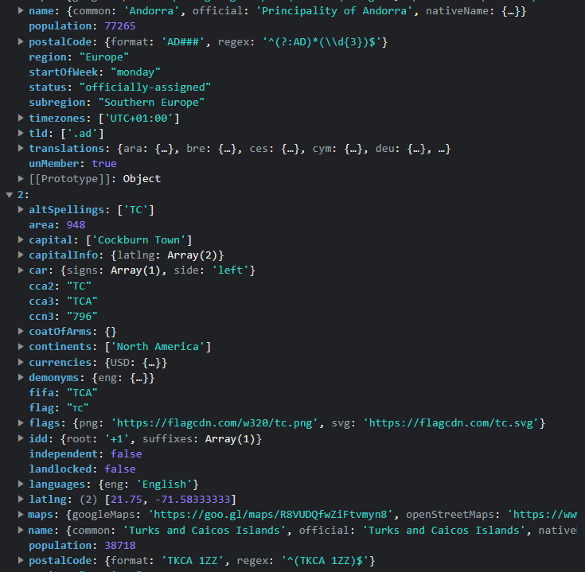

1. **Name, capital, and flag using foreach:**

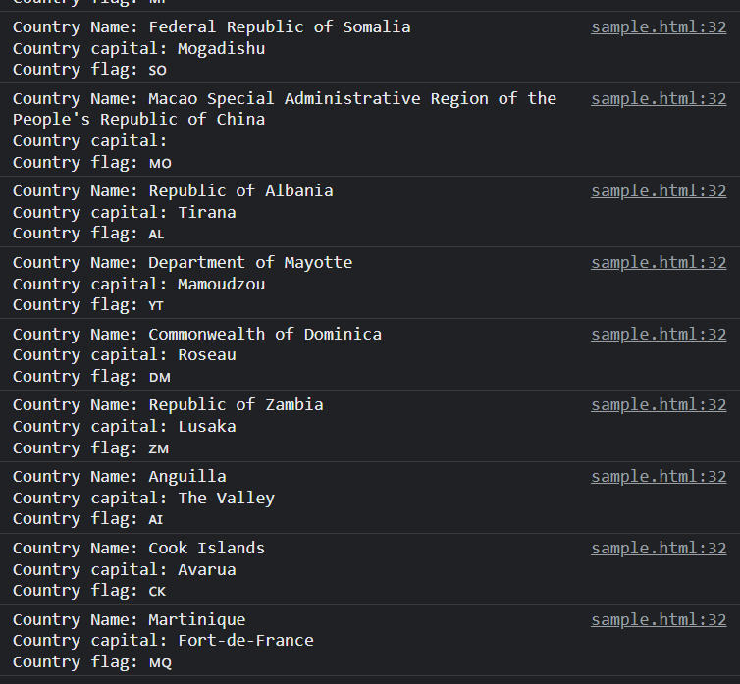

1. **Total population of countries using reduce function:**

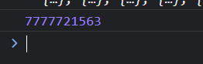

1. **Print country which has US dollars as currency:**

